Event Report: Outreach Program on Academic and Career Guidance
Organized by: Equal Opportunities Cell (EOC), G. Pulla Reddy Engineering College (Autonomous).

An outreach awareness program was organized by the Equal Opportunity Cell (EOC) of G. Pulla Reddy Engineering College (Autonomous) at Birla Open Mind International School, located in Nannur village near Kurnool.
Venue: Birla Open Mind International School, Nannur Village, Kurnool, Andhra Pradesh

Date & Time: Thursday, October 1, 2026 (11:49 AM – 12:27 PM)
Overview
The Equal Opportunities Cell (EOC) of G. Pulla Reddy Engineering College organized an awareness and outreach session aimed at guiding school students on higher education, skill development, and career opportunities. The interactive event focused on providing equal access, equal rights, and empowering students to make informed educational choices.
Key Presentation Topics Covered
- Core Values of EOC: Introducing the mission of equality, inclusion, respect, empowerment, and unity in diversity.
- Entrance & Scholarship Opportunities: Detailed guidance on merit-based admissions, government scholarship programs, and financial support schemes for higher education.
- IIIT / RGUKT 6-Year Integrated Courses: Step-by-step overview of post-10th grade admission pathways into 6-year integrated B.Tech programs.
- Skill Development & Short-Term Courses: Highlighting job-oriented vocational training including web development, solar/electrician technical skills, graphic design, and short-term certifications.
- Vocational Courses & Apprenticeships: Discussing hands-on industry-based practical training, stipends, and workplace experience programs.
- Pre-Application Checklist: Essential advice on eligibility criteria, verifying official notifications, and application procedures before applying.

Key Highlights
- Active Engagement: College student volunteers and faculty members presented interactive digital slides on smart displays to deliver structured guidance.
- Student Participation: Attending students listened attentively, participated in discussions, and clarified their queries regarding post-10th educational pathways.
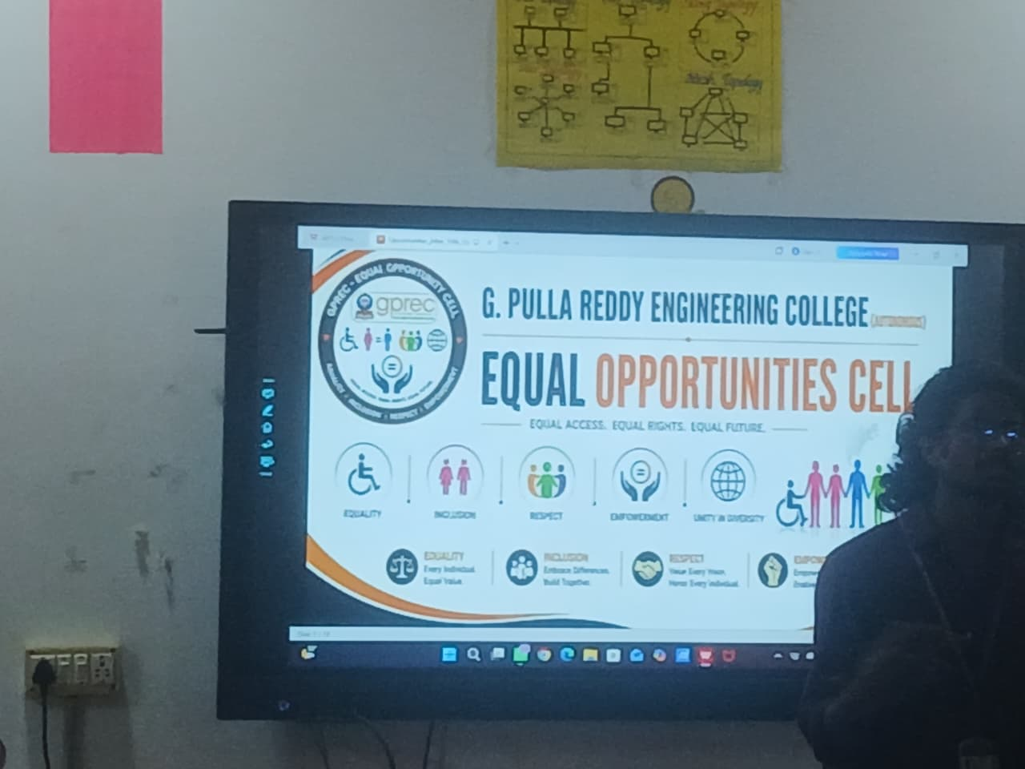
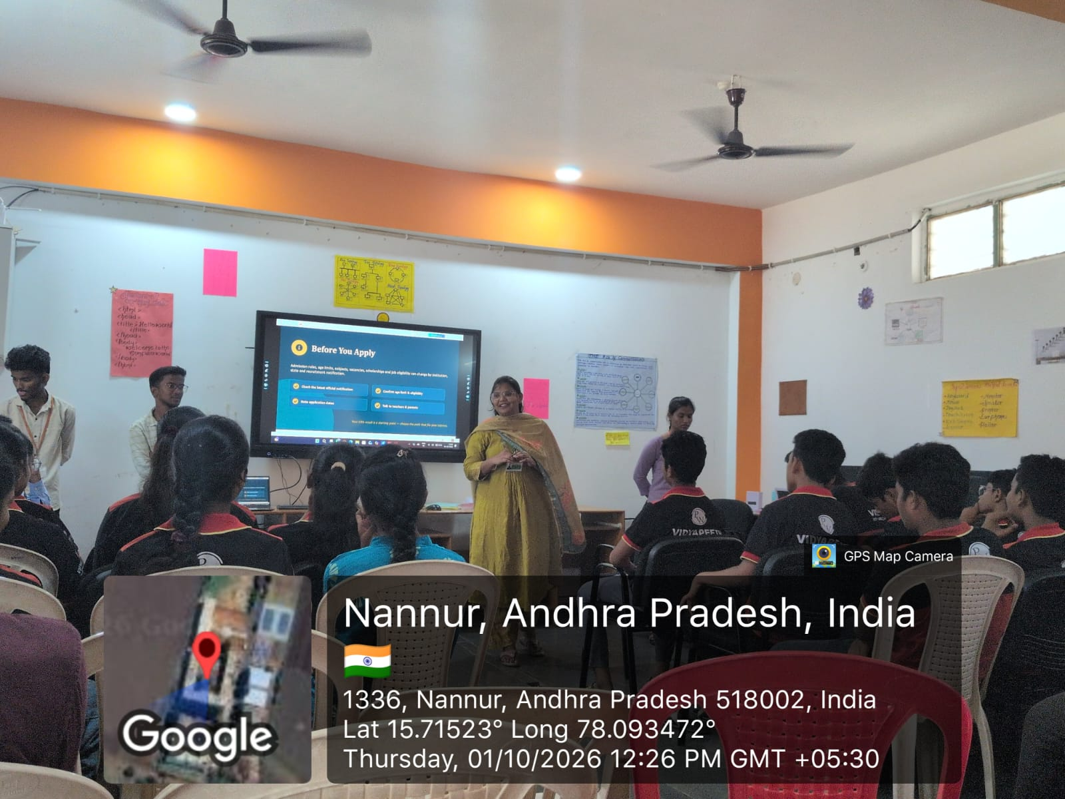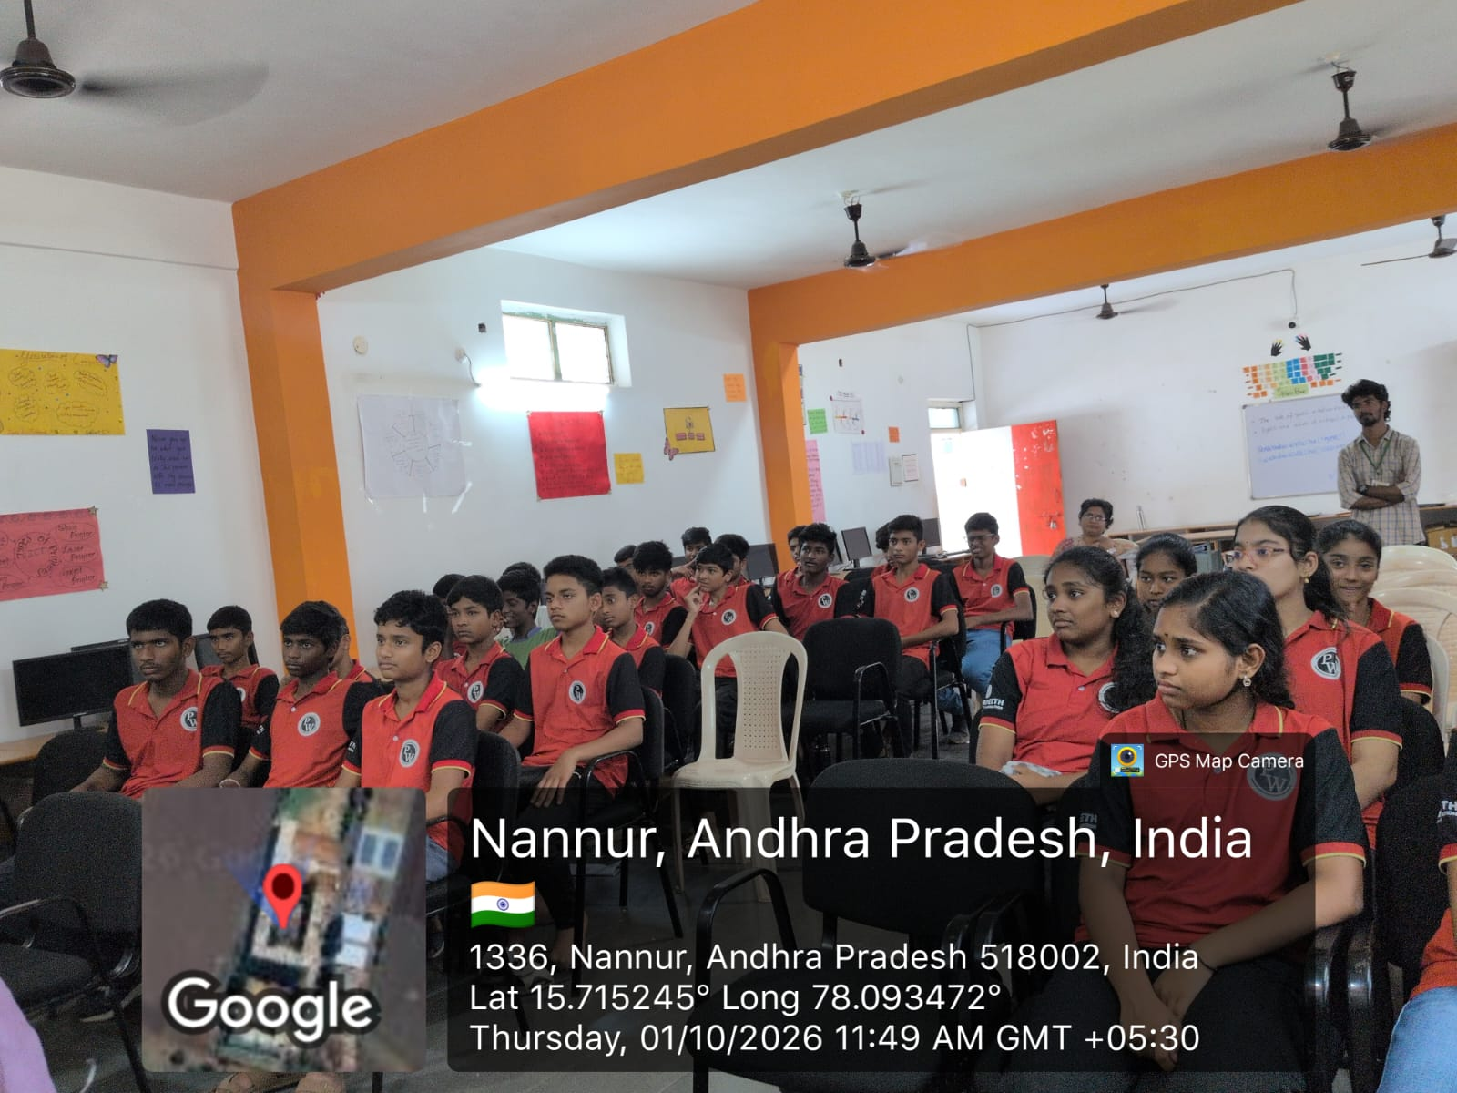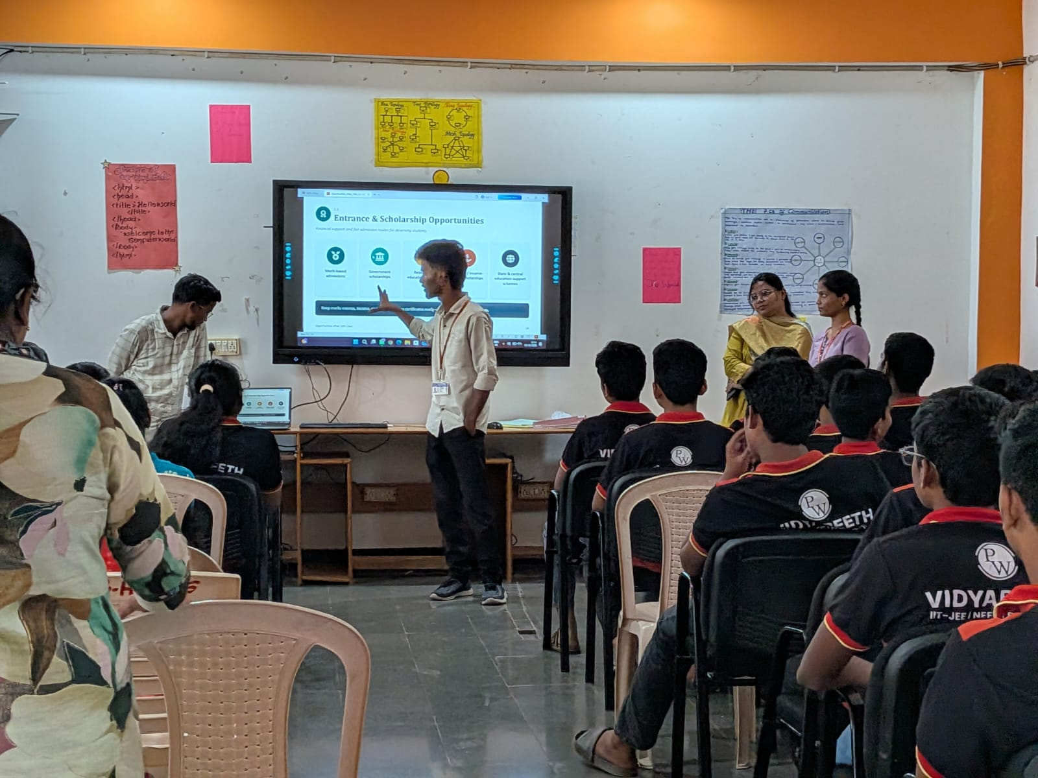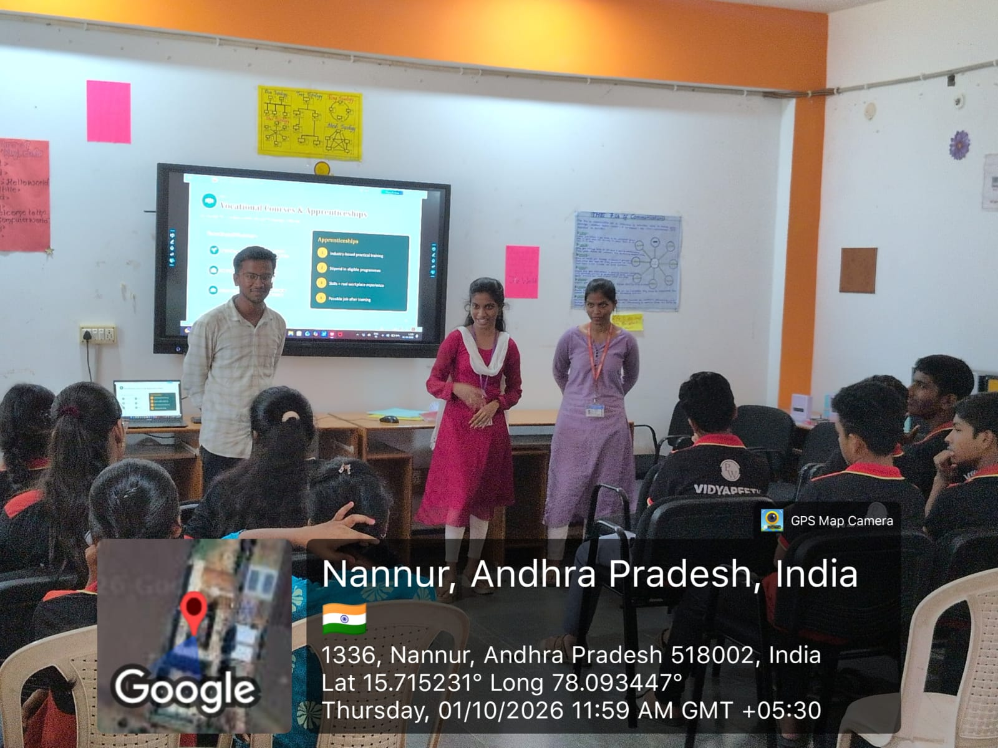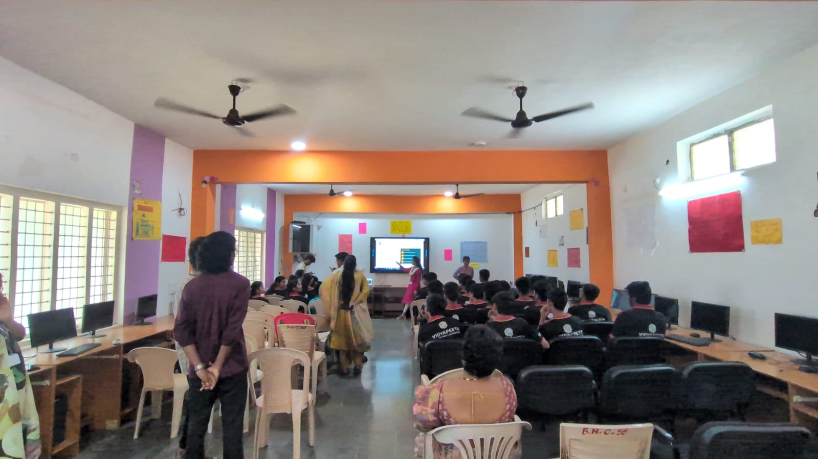

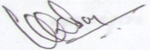
Signature of the Liaison Officer

(Dr. GVR Sagar)

