G. Pulla Reddy Engineering College (Autonomous): Kurnool
Electronics & Communication Engineering

Total Faculty List

Under Graduate :

S.No. | Name | Qualifications |  |  |  | Aadhaar No. | PAN No. | Photo | University Ratified | Bank Account num to which Salary Credited
 |  | SSC Certificate No. | UG Certificate No. | PG Certifiate No. | Ph.D Certificate No.
 | Dr.S.Nagarajarao  Professor & H.O.D | 856365 | B42957 | 1322 | CC031115 | 487067866601 | AIGPR0261G | 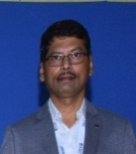 | Yes | 152110027000053
 | Dr.K.Suresh Reddy  Professor | E0051381 | 0005 | 2K16156 | RF454019 | 452636869775 | AHMPK8416B | 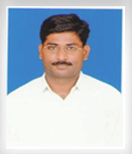 | Yes | 152110025031199
 | Dr.P. Abdul Khayum  Professor | 580765 | 86EC501 | G30789 | CC051356 | 681693493042 | AMFPP7953E | 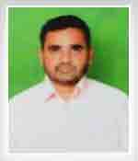 | Yes | 152110100061017
 | Sri. M. Devendra  Associate Professor | 523830 | BT090518 | 39/N0107/94HZ05013 |  | 526847382696 | ADDPM2898Q | 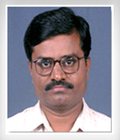 | Yes | 152110025031035
 | Dr. D.R. Srinivas  Associate Professor | 917383 | 89428 | 39/010N/98HZ05004 | 17400025 | 228275870951 | AEQPD1785D | 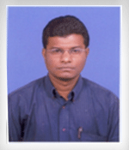 | Yes | 152110025031131
 | Dr. SalaiThillaiThilagam  Associate Professor | 1297486 | 5838 | 2957 | 005339 | 920938975449 | BUJPS4002E | 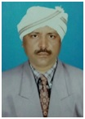 | No | 152110100097881
 | Dr.M.V.RVittal  Associate Professor | K147009 | B15065 | 553 | CC005804 | 648261168919 | ADUPV1536H | 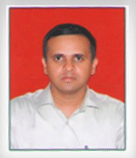 | Yes | 152110100006427
 | Dr.SM Shamsheer Daula  Associate Professor | N222306 | AA13084 | 2155 | 000064 | 434033369326 | AXCPS3941B | 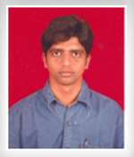 | Yes | 152110021050873
 | Dr. S. Vyshali  Associate Professor | SCH6111 | A29320 | CC144924 | CC033890 | 500404148933 | BOHPS4226N | 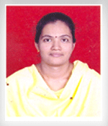 | Yes | 152110011042371
 | Dr.R. Sudheer Babu  Associate Professor | L0060783 | 563 | 4300 | 000215 | 374065412168 | AJDPR2116C | 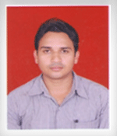 | Yes | 152110011040944
 | Dr.G.V.R. Sagar  Associate Professor | 071999 | 0140 | 00574 | 685215 | 409710098226 | ALHPG5676J |  | Yes | 152110027000054
 | Dr.D.Rajasekhar  Associate Professor | 0336316 |  |  | 067158 | 852854254490 | ALQPR9572B |  | No | 19510011011361
 | Dr. G. Amjad Khan  Associate Professor | M340156 | 2K-3/094250 | 2156 | 000395 | 641261373728 | AMKPG1382M | 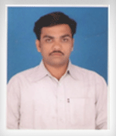 | Yes | 152110011041027
 | Dr.D. Lakshmi Chaitanya  Associate Professor | 0374067 | 20014011 | 481304 | A64576 | 424885251077 | AKSPD5579K | 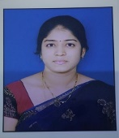 | No | 10812041004797
 | Smt. K. UdayaKiran  Assistant Professor | C0157082 | B06608 | 87845 |  | 373850099154 | AVJPK2930R | 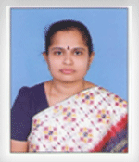 | Yes | 152110021031471
 | Sri. B. Siva Reddy  Assistant Professor | J010747 | AA14647 | 914 |  | 713051208337 | AQFPB9364D | 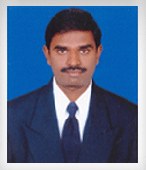 | Yes | 152110011041031
 | Sri. T. SarathBabu  Assistant Professor | J082218 | M37-E-B1-GE-2341 | 96GEEE2083 |  | 925456188622 | AHVPT9387M | 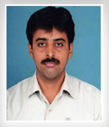 | Yes | 152110025060041
 | Dr. G. Ramesh  Assistant Professor | AMP742523 | 29942 | 146411 |  | 737327984124 | AYCPG6315L | 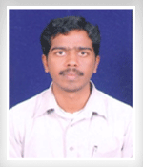 | Yes | 152110100021310
 | Smt. C. Rajeswari  Assistant Professor | L0318530 | T002440 | PCA1003 |  | 469384305535 | AYQPC2310M | 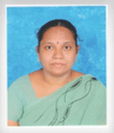 | Yes | 152110027000045
 | Sri. L Lakshmi Prasanna Kumar  Assistant Professor | N218438 | AA13071 | 902 |  | 758014031280 | AEZPL3259F | 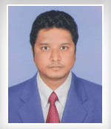 | Yes | 152110100043589
 | Sri. K. Raju  Assistant Professor | AMP616699 | AA44811 | CC013687 |  | 428803289294 | AYUPK1147J | 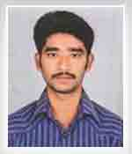 | Yes | 152110100060018
 | Smt.T. Swathi  Assistant Professor | AMP632495 | AA49138 | 7144 |  | 774453876408 | AJMPT1902H | 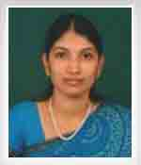 | Yes | 152110100060027
 | Sri. D. Sharathbaburao  Assistant Professor | AMP628105 | 626979 | OU288397 |  | 231991706941 | AUDPR4401R | 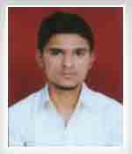 | Yes | 152110100060744
 | Sri. S. Siva reddy  Assistant Professor | NM201713 | 8851 | CC058705 |  | 380160126620 | EKBPS0254P | 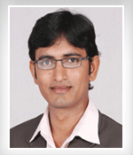 | Yes | 152110100045824
 | Sri. A VenkataSubbareddy  Assistant Professor | BB244885 | 2432 | N11-00329 | - | 892414719567 | BACPA7297Q | 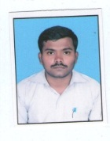 | Yes | 152110100083772
 | Ms. W. Yasmeen  Assistant Professor | 394691 | E220803 | CC284645 |  | 529473851635 | ADJPY0357Q | 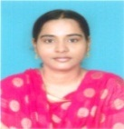 | Yes | 152110100084027
 | Smt. M.Chaitanya  Assistant Professor | TW3421879 | 04BCE27 | CC091494 |  | 935703515289 | AVBPM2172R | 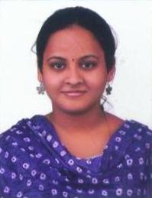 | No | 152110100031706
 | Smt. G. DivyaPraneetha  Assistant Professor | EE282595 | PC0056857 | 0998 |  | 339130796767 | AWEPG4069M |  | No | 112510100041934
 | Sri. K. Naga Koushil Reddy  Assistant Professor | AA372266 | 1648 | 00525524 |  | 310387810005 | BTYPK9070Q | 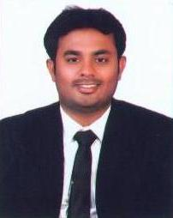 | No | 152110100031715
 | Dr. D.V.  Srihari Babu  Assistant Professor | 071887 | AI2627 | 2000-443 |  | 541882730085 | AIYPB1148G | 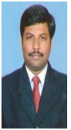 | Yes | 152110100097720
 | Sri. K. Rama Krishna  Assistant Professor | EE280251 | CC036365 | CC113994 |  | CKSPK7369A | CKSPK7369A | 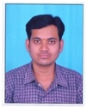 | No | 124310100117112
 | Sri. G. Pavan Kumar  Assistant Professor | GG0453483 | CC090727 | CC025474 |  | 331963360076 | CEZPG5702A | 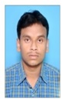 | No | 152110100097809
 | Sri K.C. Raghavendra  Assistant Professor | HH 0435205 | PC/JNTUA/JA 1471 | NITA/P/18/16PEC007 |  | 612412699051 | EFJPK2171C | 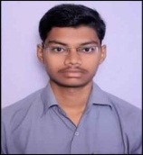 | No | 20294309499
 | Smt.P.Bindu Swetha  Assistant Professor | 530470 |  |  |  | 323416532704 | AUHPS8516Q | 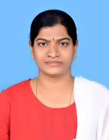 | No | 152110100113435
 | Smt.A.Parvathi  Assistant Professor | 0157082 | 01701A 0429 | 016528 |  | 204880369819 | ALQPA6537P | 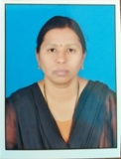 | No | 152110100040315

Electronics and Communication Engineering (PG)

S.No. | Name & Designation | Qualifications |  |  |  | Aadhaar No. | PAN No. | Photo | Univ. Ratified Yes/No | Bank A/c No. to which salary credited
 |  | SSC Certificate Number | UG Certificate Number | PG Certifiate Number | Ph.D Certificate Number
1 | Dr. ShaikSahebBasha  Ph.D  Professor | PC/16/100208 | 606 | G30767 | CC000025 | 588266432884 | AHSPB3520B |  | Yes | 152110100098093
2 | Thammi Reddy T  Associate Professor  M.Tech | G374808 | 801 | 221 |  | 400691682380 | ABRPT3608H | 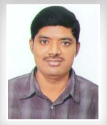 | Yes | 152110100047211
3 | M.Madhusudhan Reddy  Assistant Professor  M.Tech | 107239 | 6919 | 15803027 |  | 800791016763 | ANKPM5625Q | 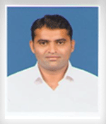 | Yes | 152110100000362

